## 

**Disclosures:**

**Ownership and material conflicts of interest:**

The author(s), or a member of their household, of this report, does not hold a financial interest in the securities of this company.

The author(s), or a member of their household, of this report, does not know of the existence of any conflicts of interest that might bias the content or publication of this report.

**Receipt of compensation:**

The compensation of the author(s) of this report is not based on investment banking revenue.

**Position as an officer or director:**

The author(s), or a member of their household, does not serve as an officer, director, or advisory board member of the subject company.

**Market making:**

The author(s) does not act as a market maker in the subject company’s securities.

**Disclaimer:**

The information set forth herein has been obtained or derived from sources generally available to the public and believed by the author(s) to be reliable, but the author(s) does not make any representation or warranty, express or implied, as to its accuracy or completeness. The information is not intended to be used as the basis of any investment decisions by any person or entity. This information does not constitute investment advice, nor is it an offer or a solicitation of an offer to buy or sell any security. This report should not be considered to be a recommendation by any individual affiliated with CFA Society of San Francisco, CFA Institute, or the CFA Institute Research Challenge with regard to this company’s stock.

## 

Recommendation: **BUY** | Current Price: **USD 152.13** | Intrinsic Value: **USD 155.18**| Downside: **33.68%**

## 

## **MARKET PROFILE**

Stock Rating **Overweight** 52-Week Range **$70.06 - $166.82**

YTD Change / % **3.71%** Shares Outstanding **172.21M**

Date **02/03/2021** Industry View **Positive**

Market Cap **USD 25.58B**

## EXECUTIVE SUMMARY-----------------------------------------------------------------------------------------------------

The recommendation for First Republic Bank's security is a **BUY**. The growth in AUM and the stable growth rate of their wealth management business indicates confidence that FRC will keep increasing its market shares in the banking industry and outperform peers. The bank's product offerings are well-positioned to continue to capture market share. It is a growth company with excellent customer reviews and solid execution in product development.

Using several valuation models, the team got an implied price per share of $145.31, a downside of 33.68% from FRC’s closing price as of February 2, 2021 of $152.12. Most companies are currently overvalued as many people are optimistic that the economy will expand after the pandemic is over. This assumption is strengthened by the current distribution of the Covid-19 vaccine.

***Strong deposit growth****:* FRC’s core deposits have been growing at a healthy rate of 18% CAGR over the past five years, a strong growth compared to the US banks’ average deposits growth rate of 5.14%. FRC’s deposit base as of year-end 2019 was about $89B, with checking deposits making up 59% of the deposit base. FRC’s total deposits as of September 30, 2020, was $104B, an increase of 15.38% compared to total deposits as of year-end 2019 of $90.13B. The strong growth demonstrates FRC’s ability to offer desirable products and maintain good customer relationships.

***Low charge-off rate compared to industry:*** FRC’s charge-off rate as of year-end 2021 was 0.00%, while the top 50 U.S. banks had an average charge-off rate of 0.25%.

***Weak cash flow for the past four quarters****:* From September 2019, FRC’s free cash flow has fallen from almost $2,000M to less than $200M. Undoubtedly, the Covid-19 pandemic is one of the influencing factors.

***Intense competition in the sector****:* The financial sector faces both internal and external competition. Non-banks, such as fintech firms and others, can offer financial products and/or services, which further increases the sector’s competitiveness. The biggest banks are able to provide a wider scope of services and products to customers, oftentimes making them more attractive than smaller banks. As FRC is the 25th biggest bank in the U.S., it also boasts extremely strong customer relationships, desirable products and services, as well as maintaining low charge-off rates in an attempt to remain attractive. FRC currently is considered to offer superior customer relationships, which is a major part of the bank’s business strategy. The bank's fintech sector is *lackluster* as client testimonials indicated archaic software in their online banking platforms. *Eagle Invest* is their automated robot-advisor that handles client investments. Despite its high balance requirements and fees, it has been well-received by customers.

***Changing regulation:*** Basel IV, which is due to be implemented in 2023, will make amends to the current Basel III requirements. Essentially, Basel IV will limit the reduction in capital that may arise from the use of internal models under the Internal Ratings-Based approach.

## BUSINESS DESCRIPTION----------------------------------------------------------------------------------------------------

First Republic Bank was established in 1985 and headquartered in San Francisco. It was founded by James Herbert as a small thrift company. As of December 31, 2020, First Republic Bank accumulated total assets of $133.2 billion and deposits of $90.1 billion. First Republic Bank ranks as the 25th largest U.S. banking organization as determined by total deposits with over 4,000 employees. First Republic Bank operates predominantly in the wealth management and commercial banking industry.

***1. Company's History:*** First Republic Bank first went public in 1986, just one year after it was founded. First Republic was sold to Merrill Lynch in 2007. During the 2008-10 financial crisis, Bank of America bought Merrill Lynch. In July 2010, Bank of America sold FRC to private equity firms General Atlantic and Colony Financial. This firm brought back CEO James Herbert to lead the Bank once again.

First Republic Bank had its second IPO in December 2010. 11,000,000 shares were priced at $25.50, bringing the company’s market cap to $280.5M. Bank of America, Morgan Stanley, and J.P. Morgan were all joint book-running managers. Three months before the second IPO, First Republic Bank’s assets totaled $22.0B, the bank’s deposits totaled $19.0B, and wealth management assets totaled $17.2B.

As of January 28, 2021, First Republic Bank announced a $650M preferred stock offering. The preferred shares are offered at $25.00 per depository share, with each representing a 1/40th interest in its 4.25% Noncumulative perpetual Series L Preferred Stock. First Republic’s underwriters have up to 30 days to purchase an additional 3.9M depository shares. The company announced it plans to use the proceeds from the offering to redeem its Noncumulative Perpetual Series G preferred stock.

***2. Financial Highlights:*** Over the past five years, First Republic’s stock price rose by 129.1%, outperforming the Russell 1000 Index’s performance of 102.8% over the same five years by 26.2%. First Republic stock price’s CAGR was 18.1% over the past five years, while the Russell 1000 Index’s CAGR was 15.2%. Over the past year, the bank outperformed the Index by 12.2% by achieving a 28.3% increase in its stock price compared to the Index’s return of 16.1%.

Currently, First Republic is trading at 25.22 times its trailing 12-month EPS. First Republic’s historical 5-year median Price/EPS has been 21.22. Its current Price/Book Value is 2.6, compared to its 5-year median of 2.2 and 10-year median of 2.0.

First Republic’s current net margin is 21.2%, which is lower than both its 5-year average of 23.7% and 10-year average of 24.4%. Its return on equity and return on capital are both lower than the 5-year and 10-year average. The bank’s return on equity is currently 10.2% while its 5-year average is 8.1 and 10-year average is 8.1; its return on capital is 7.8% compared to its 5-year average of 0.8 and 10-year average of 0.9.

***3. Products and Services:*** First Republic’s services and products target high-networth individuals.

Lending Products: Single Family Real Estate loans account for 53% of the company’s loan portfolio. As of year-end 2019, these single family residential loans had an average loan-to-value ratio of 58%. First Republic offers a higher average family loan size ($706,000 being the median loan size) and therefore only loans to families with good credit and a high net worth ($591,000 being the median liquid assets). Multifamily loans take up the second largest piece of the pie, making up 14% of the company’s loan portfolio. Multifamily loans are predominantly for established buildings with “proven occupancy, rental rates and expense levels'' (10-K, 2020).

The main differentiation in their products and services is their customer service. The management and relationship-building executed by FRC over the past decade was a strong diver in capturing market share from other banks. Reviews along with positive and negative testimonials about the bank are discussed further on in the equity research [6. Commercial Banking].

Gathering Deposits: First Republic Bank’s total deposits had a CAGR of 18% from 2015 to 2019 compared to the average deposit growth rate of US banks at 5.14%. As of December 31, 2019, the company’s checking deposits made up 59% ($52.8 billion) of the deposit base. Money market checking as well as savings and passbook deposits made up 26% ($23.4 billion), and CDs made up 15% ($13.9 billion). The majority of deposits (56%) come from business clients as of year-end 2019.

Private Wealth Management: First Republic Bank’s private wealth management activities include investment management services, which provide traditional portfolio management; brokerage and investment activities, which offer brokerage services for funds and brokerage clients through FRSC; insurance services, more specifically annuities and life insurance policies; trust company, which attracts both clients from the current client base and new clients; foreign exchange, where the bank earn fees by transacting foreign exchange. As of December 31, 2020, the company’s assets under management reached $194.5 billion.

***4. Business Strategies:*** Originate High Quality Loans: First Republic Bank aims to underwrite high quality loans for both existing and prospective/new clients. To do so, the company only underwrites loans to qualified clients, which helps the company maintain a credit quality that is higher than the industry average.

Grow core deposits: Core deposits, “which include checking accounts, money market accounts, savings accounts and… CDs” have a CAGR of 18% from 2015 to 2019 (10-K, 2020). These core deposits make up 90% of the company’s deposit base. The company strives to maintain this growth rate by managing existing and new relationships with clients, branching out to and networking with prospective clients, and hiring high quality professionals and staff.

***5. Ownership Structure*:** About 95% of the company’s shares are held by institutional investors. The company’s 10-K for the year 2019 reported that “fewer than 20 shareholders [were] of record, although the Bank believes… its shares are held… by approximately 185,000 shareholders” (10-K, 2020).

## INDUSTRY OVERVIEW AND COMPETITIVE POSITIONING---------------------------------------------------------

The commercial banking industry is characterized by strict regulations, low technological interruption, and intense external competition by both bank and nonbank organizations alike. The industry’s revenue annual growth was 3.5% from 2015 to 2020 and is forecasted to increase to 4.3% from 2021 to 2025. One of the primary ways the industry generates revenue is the prime rate, or the rate a bank charges its most creditworthy customers, usually another bank or a big corporation. The prime rate has decreased due to the federal funds rate being reduced to effectively 0%, which poses a threat to the commercial banking industry. The Covid-19 pandemic has negatively impacted the commercial banking industry, yet the industry is forecasted to resume growth after the pandemic is over with a rise in profitability and revenue growth.

**Industry Overview**

***A low federal funds rate (FFR) will cause industry revenue to decrease:*** The federal funds rate was increased eight times from 2015 to 2018, which increased revenue for financial institutions. Revenue in this case is calculated as interest income combined with noninterest income, with noninterest income being fees such as overdraft or account maintenance fees, and interest income being the spread between interest-bearing deposits or accounts and loans. With the rising FFR from 2015 to 2018, financial institutions were able to increase interest income.

However, since the Federal Reserve lowered the FFR to effectively 0% in 2020 to combat the negative economic effects the Covid-19 pandemic brought, both the prime rate and the spread between interest-bearing accounts and loans have decreased. The decrease in the prime rate is a potential threat to the commercial banking industry as it may significantly decrease industry revenue. So far, the prime rate has decreased from 4.90 in 2018 to 3.30 in 2020.

***Government regulations may significantly decrease industry profitability:*** In 2008, in an attempt to restore consumer confidence in commercial banks after the Great Recession, the FDIC’s Board of Directors increased the deposit insurance by 2.5x, from $100,000 to $250,000. While this policy contributed to restoring consumer confidence, it has caused commercial banks to experience a significant increase in regulatory expenses and a decrease in borrowing and investing power. Coupled with the coronavirus pandemic in 2020 and the negative financial impact it brought to many people, some industry operators are putting aside more capital to combat anticipated losses of loan. The commercial banking industry profitability is expected to be 7.7% in 2020, a significant decrease from 22.7% in 2015.

***Intense external competition by both bank and nonbank organizations:*** The organizations that operate in the commercial banking industry face high competition from other financial institutions such as credit unions and mortgage brokers. There has also been an increase in nonbank organizations offering financial services, such as the trading app Robinhood and retail chains like Target offering debit cards. This further poses more competition to the commercial banking industry. Additionally, many consumers now expect technological services that allow them to perform financial services on mobile, such as transferring money, depositing checks, setting budgets, etc. Commercial banks that still heavily rely on providing brick-and-mortar services need to quickly adapt to these demands to avoid having a competitive disadvantage.

To combat the economic effects of the Covid-19 pandemic, many banks are now waiving fees such as overdraft fees. While this benefits consumers, especially those who are struggling financially because of the pandemic, it 1) decreases commercial banks’ noninterest income and 2) gives banks that do not waive these fees a competitive disadvantage.

**Outlook and Trends**

***Bank lending is expected to increase with rising FFR:*** When the pandemic is over, the FFR is expected to increase over time. The prime rate is expected to rise from 3.3% in 2020 to 4.0% in 2023, which should increase industry revenue. Along with improving economic conditions is the higher demand for loans, which will also contribute to increasing industry revenue. With higher industry revenue, the industry profitability is forecasted to increase from 7.7% to 23.6% in 2025.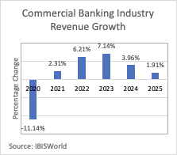

***The regulatory environment is expected to be stricter:*** Banks must comply with acts such as the Bank Holding Company Act, the Dodd-Frank Wall Street Reform & Consumer Protection Act (commonly known as Dodd-Frank), etc., which puts pressure on banks to increase regulatory-related expenses.

***Technological disruption is expected to be low:*** The biggest technological disruption in the commercial banking industry was from Social Finance Inc., a company that provides banking services via its website and app only. Otherwise, new patent technologies are slow to develop in the industry. However, this does not mean there is no exposure to technological disruption, but only that the rate of technological innovation development is low enough that there is no unforeseen major technological disruption.

***Improving operating conditions with an economic expansion:*** With the Covid-19 vaccine now available in many countries, the world is beginning the process of moving past the Covid-19 pandemic. When the pandemic passes, the Fed will again raise the FFR from the current 0%. As macroeconomic conditions recover from the pandemic and subsequently improve, disposable income per capita is expected to increase at an annualized 1.2% from 2021 to 2025 (See appendix 20, figure 2). The increase in disposable income per capita will further stimulate the economy by increasing spending per capita. The demand for financial services such as mortgages and credit cards will also rise, which will profit the commercial banking industry.

**Competitive Positioning:** First Republic Bank’s creditworthiness is above average compared to the top 50 U.S. banks. First Republic has achieved this creditworthiness by giving loans to creditworthy clients with a high net worth ($1 million investable assets or more). The bank’s loan growth comes from the residential real estate loan portfolio, which has a much higher annualized yield than the U.S. Treasury bill’s yield. First Republic also aggressively invests its deposits, which is reflected by the high loan-to-deposit ratio.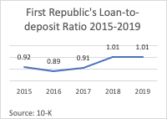

***Superior credit:*** First Republic Bank focuses on lending to clients with a high net worth and creditworthiness. The bank defines borrowers who carry little risk as households with $1 million or more in investable assets. First Republic’s creditworthiness is above average in the commercial banking industry with an annual charge-offs rate (the rate of debt obligations that are not likely to be collected) of 0.00% compared to the top 50 U.S. banks’ rate of 0.25% (Tor and Sikander, 2020).

***Strong loan-to-deposit ratio:*** Over the last five years, First Republic Bank has a strong deposit CAGR of 13.5%. Its loan also has a CAGR of 15.5%. The CAGR of deposits and loan are quite close and is further emphasized by a loan-to-deposit value of almost 100% in 2019 in the third quarter of 2020. Compared to the industry’s average loan-to-deposit ratio of 69.5% (Tor and Sikander, 2020), First Republic’s loan-to-deposit ratio is outstanding. More importantly, most of First Republic Bank’s loan growth comes from residential real estate loans, a portfolio that has an annualized return of 2.96% in 2020’s third quarter (Tor and Sikander, 2020). Compared to banks that invest in U.S. Treasury bills that have a much lower yield, First Republic Bank’s investment decisions offer a much higher yield.

***Strong free cash flow:*** First Republic demonstrated a strong free cash flow growth from 2015 to 2019 (See appendix 20, figure 1). Most of the growth comes from Cash Flow from Financing Activities. From 2015 to 2019, First Republic’s free cash flow grew at a CAGR of 20%. Both net operating cash flow and net financing cash flow grow at a healthy rate, which signals that First Republic is thriving.

INVESTMENT SUMMARY--------------------------------------------------------------------------------------------------

Based on the encouraging prospects of the richly-valued stock price and competitive advantages held by the bank among the other industry players, the overall outlook on financial performance is positive. The following arguments are the pivoting indicators for the "BUY" recommendation and assessment of the attractiveness of this investment.

***Company growth:*** Over the last 5 years, FRC has undergone a growth in stock price of over 147% despite crippling low growth rates in the banking industry. They were able to capture market share quickly by attracting more and more customers through existing customers (50%) and referrals (25%). The growth in their Assets Under Management (AUM) is also to underline as the bank went from $99 billion in AUM to $156 billion in a 6 years period.

***Setbacks in Financial performances:*** Although their recent underperformance with their cash flow due to the ongoing pandemic. FRC rests on a history of strong cash flow growth in the 4 Years period prior to the pandemic.

***Undervalued Stock-price:*** After analysis of the intrinsic value of FRC’s stock, the difference with the market price clearly outlines an undervaluation of the stock by 1.76% .

***Litigation History***: a key element that enabled FRC to steal market shares to customers is their relatively inexistant legal history with unsatisfied clients. Compared to major banks and direct competitors, FRC has 53 known court cases against more than 2470 cases for the more traditional Wells Fargo.

PRODUCT ANALYSIS---------------------------------------------------------------------------------------------------------

First Republic Bank’s product line consists of many diverse and generic banking products largely offered to customers. However, for the purpose of this report, we decided to take a closer look at the bank’s products and the trends that shape the market behavior, and how that will affect the bank’s valuation and performance in the future. It is our belief that having a better understanding of the products, as well as their impact on the bank will help us assess many factors related to this investment proposal.

As aforementioned, First Republic Bank mainly operates in the San Francisco Bay Area among other local and global banks. Banks such as Wells Fargo, Bank of America, East-West Bank, and Bank of the West are among FRC’s direct competitors in the region. Currently ranking 4th in terms of product quality, FRC holds itself quite well despite the discrepancy in size between itself and its larger direct competitors. First Republic Bank has quite the ranking among peer banks in the Bay Area, with

FRC concentrates on two main product lines: commercial banking and wealth management. They have met with consistent success in the past decade. Will this continue? We looked at these two product lines carefully to answer that question. On one side we have commercial banking activities, which are well ranked among customers due to outstanding customer service. Their deposits, saving & checking accounts, and MMAs are among the best ranked in the region of San Francisco. FRC's second product line, wealth Management, has met with even greater success , in terms of growth, than commercial banking. On the other side, a domain in which the bank seems to be quite successful is the wealth management business. Indeed, the bank’s wealth-management focused subsidiary, First Republic Wealth Management, has more than $34.90 billion in total assets to manage overseen by 48 portfolio managers and 13 analysts.

A more detailed breakdown of these two main product lines is necessary in order to establish the level to which products and their future in the industry will determine the fate of the bank. Therefore, we are going to look at the following aspect of each product line.

***6. Commercial Banking:*** In analysis of First Republic Bank's product line and business model, it is perceptible the company operates under the goal of not competing with the largest banks in the country; which FRC by over USD 2 trillion assets. The bank primarily focuses on two customer segments: high-networth individuals as well as startups and founders. While many other banks demonstrate aversion to these investments, FRC has shown accessibility towards loans with a riskier profile. With its tagline, "banking for innovators", it differentiates itself from the likes of its counterparts while operating heavily in California's startup-focused Bay Area.

***Business Model and Operations:*** Under commercial banking, FRC’s performance throughout the past decade has solidified itself in the industry. In relation to this aspect of the bank's operations, the services offered are similar to industry standards. Savings, checking, money markets, and loans predominantly dominate the business model alongside the wealth management services. The bank fails to participate in areas where a lot of its other competitors operate such as currency swaps, IPO underwriting, subprime lending, amongst many others. Customer service is one of the FRC's main concerns as it applies heavy resources towards providing the most impressive quality possible. Online testimonials and other reviews reflect the effort and are often highly commemorated as FRC's primary success lever (First Republic Bank Exhibit 99.1, 2021).

***Deposit Performance and Strong Predictors:*** Deposit growth is a major factor for determining profitability in the banking sector. FRC offers deposits funding, per industry standards, along with mobile and direct options. The performance since 2015, with a compound annual growth rate of 19%, demonstrates First Republic's ability to develop and execute a desirable product for its customers. In forecasts for future product line innovations and expansions, this data serves as a strong predictor for profitability and customer growth. In order to continuously maintain the performance over the next decade, the bank will need to focus on customer service and product innovations, while continuing to target more of its largest demographic's market share from other competing banks. One prime example would be First Republic's activities in writing loans for the Small Business Administration Paycheck Protection Program. Further solidifying their brand image with such operations will build the bank's reputation as the most desirable branch for startup growth (First Republic Bank Exhibit 99.1, 2021).

***Competitors Comparison:*** The products' growth of 67% above the national average along with a strong recovery after the March 2020 crash, allow a reasonable forecasting of continued strong performance in the coming years. Net charge-offs performance for the bank was strong in comparison to national averages (33 bips less), but their regional strength in the state of California, along with their comparatively lower amount of loans can titl the result. For that reason, it is crucial to compare the data with other of its main competitors. FRC ended the third quarter of 2020 with $2.4M in net charge-offs, while Silicon Valley Bank reported $24.1M and Fremont Bank $1.4M. While FRC and Fremond are closely matched, there is a 904.2% difference between SVB and First Republic. The bank's products in relation to loans and bad debts demonstrates a solid performance and strong execution by the employees.In further analysis, the majority of collaterals for those loans (81%) is real estate, which is widely regarded as a healthy aspect for a bank. Overall, FRC's deposits-to-liabilities ratios along with its loans experience allows for positive forecasting to the bank's performance in the coming years (First Republic Bank Exhibit 99.1, 2021).

***Product: Automated Investing:*** The pressure in the banking industry to compete with automated investment services offered in the market has affected FRC as well as the largest banks in the country. The newest trend in working towards returns from the financial market is artificial intelligence that functions around the clock in attempting correct decisions. The vast majority of banks offer this service at a charge in an effort to reduce the emotional factor that some clients may be subjected to. First Republic's product—Eagle Invest—is one of the market offerings. The decision to launch and develop the product is in line with their target demographic of high-networth individuals who are more likely to invest their wealth. The high minimum investment requirement of $5,000 disqualifies many customers who may be interested in the product. Wealth managers who incessantly recommend the product regardless of a client's profile also raise flags about the service being provided. Regardless, the product's multi-asset strategies and classes are desired by many customers, and reviews show positive track records (First Republic Bank, Eagle Invest).

***Customer Service: Opinion and NPS:*** Because FRC does not have the size and accessibility that other large banks in the country have, customer service must be the northstar of their operations. For success in the current banking environment, where all-time low interest rates, zero fees, and extravagant cashback deals are the norm, First Republic needs to continue delivering high performance to maintain its existing market share. Online banking and finance forums as well as review websites have shown extremely positive reception towards the bank's customer service. Primary research conducted by the team with business owners in the San Francisco and Emeryville area revealed an inconsistency in First Republic's market proposition. It presents itself as being modern and perfect to startups, but it was found their actual system is extremely archaic and tradition in the sense that the technology they provide and functionality are not up to industry standards. The system is very limited and structured in the way that does not allow for easy navigation and execution of services.

First Republic's actual system is extremely archaic and tradition despite its offering of being modern and perfected to startups. In contrast, a positive aspect from the experience was the reportedly excellent weekend telephone service and help.

Online ratings by Bankrate–a respected financial services company–ranked FRC at 2.8/5 across different aspects including CDs and Checking at average ratings, while MMAs were reported to significantly below average at 1.7/5. The primary positive appeal in the vast majority of reviews is the week-long phone customer service, indicating that weekend operations are valuable to busy high-networth individuals that are busy on business days (Goldberg, 2020).

Negative reviews were prevalent in relation to the lack of ATMs, high balance requirements, and comparatively lower APYs (Goldberg, 2020). In addition, First Republic's digital services are not as developed as some of its competitors. The bank's Net Promoter Score (NPS) resulted in extremely high results at 72 (Luck, 2018), which indicates that its service-oriented business model yielded in generally positive reviews.

***Market Share Growth:*** The bank has grown significantly over the past decade, and increased its market share continuously year by year. The analysis of potential reasons for that event begins with the positioning in the market. Following its "banking for innovators" differentiation, FRC geographically established itself and its brand in California, where startups have gained exponential success ever since the bank's inception. It was able to service these up-and-coming businesses with riskier profiles where a vast majority of the banks would look down upon. The same strategy delivered immense success to one of its competitors in the Bay Area, SVB Financial Group. First Republic Bank's execution of those products also assisted in growth. Financial and invested forums ranked the bank highly on its cost structures, deposits, and loans. FRC also leads the market in phone customer service; with its weekend availability being the most popular in testimonials. In contrast, it received negative feedback on the execution of its platform in the sense that it was extremely archaic and tradition for a bank that branded itself to be modern and geared towards startups. Estimated 50% growth in client-based comes from existing customers, and an additional 25% from referrals. The data indicates that 1 in every 4 FRC clients recommends the service to their network. As cumulative loan losses remain 0.12%, and the bank continues to keep its bad rates low in relation to the national average, the reason for the bank's growth is visible. As a result of the data on FRC's performance, the bank is expected to continue to capture market share at slow and steady rates (First Republic Bank Exhibit 99.1, 2021).

***Trends in Target Demographic:*** Customer trends in banking compared to FRC's market offerings have shown the bank is perfectly positioned to excel in today's post-recession market. The part of the population that lost their jobs during the pandemic are going to pick cheaper options that offer lower fees and balance requirements; not available at FRC. For many customers in the millennial demographic that are suffering from college debt, digital banks have a stronger appeal. Major trends in the industry have shown that more help and guidance is needed in order to navigate finances, while having the human connection help whenever needed.

In sum, First Republic Bank's products in the commercial banking sector are excellent market offerings with well-executed products that are aligned with recent markets and are continuously received with positive reviews.

***7. Wealth Management:*** Wealth management is the second biggest source of income of the bank after commercial banking products, with the subsidiary representing 17.86% of Non-interest income (2019) for the bank. This translated itself on the bank’s 2019 bottom line as $506,634 in non-interest income on their income statement. A closer look at this product and its market is thus crucial in order to establish the performance of the bank compared to its competitors. Moreover, the growth registered by the private wealth management subsidiary is quite promising.

The activities of the Private Wealth Management subsidiary consists of the following:

* Life Insurance Sales on which the bank earns revenue.
* Annuity products.
* Fees for the bank’s investment portfolio.
* Deposit earnings credit on clients’ deposit accounts held at the bank.

It is impossible to not take into account the current pandemic when analyzing the wealth management industry. Wealth managers are expected to be the center of attention of banks’ behavior within these troubled times. According to the latest report from Morgan Stanley & Oliver Wyman, the coronavirus pandemic is sure to put pressure on investment banking in general, putting the relatively stable industry of wealth management in a good light.

With FRC’s current encouraging performances, it is more likely for them to establish themselves as well established and excellent options for clients in the country. Already among the largest firms in the Bay Area, we are confident that FRC is sure to seize this opportunity and grow within and after the coronavirus pandemic. The bank has been reporting a relatively stable growth in income from interest & dividend income which could prove to be a setback in attracting more customers. However, with a quick horizontal analysis of the company’s Income statement, we can observe that there is a slight increase in net commission & fee income due to the growth of assets under management and thus of customers. This suggests that although the recent years haven’t been quite out of the ordinary for FRC, the bank is nonetheless quite attractive for customers as they rely on the fact that FRC is branding itself as a bank for innovators, thus making it a more future-focused entity. We alluded that the growth in the size of the bank is not due to strong belief in short term performance but rather on long term ones.

In their post-pandemic industry forecast, Oliver Wyman models three distinct scenarios for the wealth management industry:

* In the base case, the firm is anticipating a rather smooth transition into the new normal with policymakers successfully containing the virus and thus leading the market to go back to pre-pandemic forecasts. They foresee a recession and rebound of the market in this scenario.
* In their bull case, they base their assumption on possible prolonged support from the central bank to the market, resulting in an accelerated rebound of the industry.
* Finally, in the bear case, policymakers fail to support the market and thus slows its recovery. The expected effect is a sustained downturn in the industry.

In light of the latest progress made in the fight against the coronavirus, we are basing our assumptions and recommendations on the belief that the pandemic can still be properly eradicated. Hence, we operate in a base scenario in which 2021 will bring more stability to the industry, with a slow recovery from the 2020 fall in wealth. Therefore, it’s easy to assume that with its constant growth in size within the last years, the wealth management subsidiary of the bank will prove to be successful enough to boost the bank’s share value by the end of the forecasted period.

## FINANCIAL ANALYSIS-------------------------------------------------------------------------------------------------------

For the analysis of the bank's financial performance and valuation, ten publicly-listed companies were selected to benchmark with First Republic. The business segment of selected banks were majority in commercial banking. Calculating metrics under those relative parameters allows for a more accurate comparison between banks. Regional banks followed the standard, along with ranking on market cap. To exemplify, if Chase Bank was included in the calculations, the results would yield unreliable and skewed information since they are a much larger bank than FRC.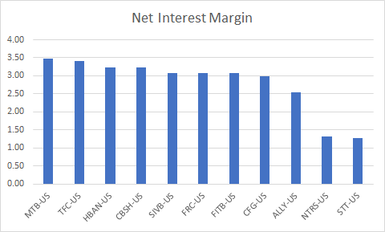

First Republic has performed well financially with calculations pointing towards a successful market positioning in comparison to other banks that reasonably forecast strong performance. In reference to profitability metrics, FRC ranked slightly higher than its peers on average, with a solid performance in its asset quality operations. The most concerning result from the calculations was the cash flow, which exhibited extensive problems year over year. It will be dissected further on the analysis.

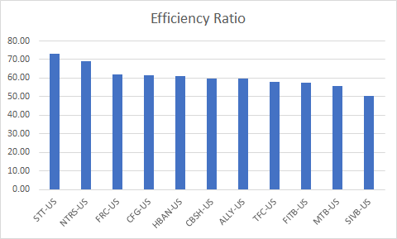

### Profitability:

***Net Interest Margin and Efficiency Ratio***: When FRC's results were compared to other regional banks, profitability yielded excellent execution. Interest margin performance was not the best amongst the sample. As shown in the graph, the bank maintains an average level throughout without weakening behind others. Efficiency ratio ranked third, indicating that profitability efficiency has a strong advantage over the others. Most importantly, they are higher than most of its peers when keeping with their business model of highly personalized service. FRC's Earning per share maintained at an average level.

***Operating:*** On the other hand, the total amount of FRC loans has been steadily rising, with a CAGR of 20.6% in the past five years, which is an amazing performance. At the same time, FRC's wealth management business is also growing at a CAGR of 15.0% in the past five years. We believe that FRC's profitability can maintain rapid growth for at least the next 10 years.

Overall, we are very optimistic about the profitability of FRC. This is because in keeping with their Hi-touch service model, FRC has very low write-offs (reflected by the 0.05 LL Reserve compared to industry standard. And its Net Interest Both Margin and Efficiency ratio remain at a relatively stable value without large-scale fluctuations.Also, they have maintained their NIM in the face of a margin squeeze (lower rate environment).

***Asset Quality:*** Strong performance was recorded in asset quality operations. Despite a loan loss provision of $600,000, actual utilization rate was relatively low. The average tends to stop at 3%, however in March of 2020, it reached over 5%. In contrast, non-performing loan accounts were 16%, which per industry standards, is an acceptable level of total loans. FRC's loan quality has stood out from its peers. This is reflected in two aspects. First, FRC's loan losses are the lowest among peers. On the other hand, FRC's Non-performing loan is also the lowest in the group. This means high-quality customers and excellent risk control. In other words, although the number of FRC loans is growing rapidly, FRC has not relaxed the quality of loans, relying on excellent resources and strict lending guidelines. Therefore, there is no doubt that FRC's asset quality level can be said to be the first in the industry for regional banks.

***Use of Cash:*** First Republic's cash flow is significantly problematic and consistently underperforming estimates. Cash flow fell for four consecutive quarters, and the report of September 2020 reported results close to zero. 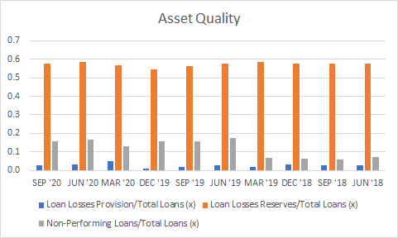

In view of FRC's fast-growing commercial banking and wealth management business, and the growing loan amount in the graph, we can be sure of FRC's current operating conditions. At the same time, based on the financial balance sheet and income statement of Q4 in 2020, this part of the decline is likely to be due to the continuous increase in cash, which has risen by approximately 3400 million US dollars this year. Although this reflects FRC's poor cash management, it is based on its Strict loan risk control. On the other hand, A large part of the free cash flow is used to repay the Federal Home Loan Banks. Therefore, we think the drop in FCF is understandable, but if this situation continues, we have to question whether FRC has grown so fast that it cannot effectively use its large amount of cash assets.

VALUATION-------------------------------------------------------------------------------------------------------------------

We used DDM, RIM, FCFE and relative models to forecast FRC's performance. Based on the mathematical results, First Republic Bank is fairly valued. We distribute 30% equally for the first three methods and 10% to the P/E model, as we treated FRC as a developing bank. We took off the weight of the P/BV valuation model in order to keep the valuation relatively reasonable and stable. Using the model weighted by the valuation matrix, the target price of FRC is $155.18 per share. Since it is now February, we should also give FRC about 2% of value compensation. Therefore, from the perspective of valuation, FRC's current share price is slightly underestimated

***CAPM:*** We set the February 1st Rate of return on LT Treasury Composite as the risk-free rate of 1.66%, and Implied ERP on February 1, 2021 as the ERP for the valuation model. Therefore, the expected rate of return on First Republic Bank Inc.’s common stock is 6.82%

***DDM Model:*** In the DDM model, we made the following assumptions: First, total loans will maintain the CAGR of the past five years in the next five years, and will slowly decline in the next five years. Second, Loan Loss Provision/Ending Loans remains unchanged. Third, Wealth Management & Other Fees will maintain 80% of the CAGR of the past five years in the next 10 years. Fourth, starting next year, due to the change of power, the tax rate will return to 25%. Fifth, the share outstanding will remain at the level of 3.33%, the CAGR of the past five years. The method we use is to use the model’s net income and the actual payment ratio to estimate the dividend payable in the next 10 years. In 20 years, the growth rate of net income decreased linearly, until a stable growth rate of 3%. Our DDM model estimates that the value of FRC is $157.73 per share. As of the end of 2020, it is higher than the market value of $144.87 at that time. Therefore, based on DDM, we believe that FRC’s stock price was slightly undervalued, but it is basically correctly valued now.

***Excess Return Model:*** In the Excess return model, we assume that the next 10 years will be in a stage of rapid growth. Since the firm earns its cost of equity after year 10, the terminal value of the company is considered to be 0. We use the current Book Value and the excess return to get The value of the company's equity is obtained by FRC's current valuation of $152.64, which is basically the same as FRC's current stock price. Of course, because we ignore the excess returns from 10 years to 20 years, the actual value of FRC should be higher than our current valuation. Therefore, according to the Excess return model, we believe that the actual value of FRC is underestimated.

***Residual Income Model (FCFE):*** The Free Cash Flow Equity was used here to determine FRC’s potencial of dividend. Key factors analyses in this valuation process include the bank’s asset base, growth rate and other income. The bank’s asset base is the revenues coming from their loans (NIM) and the fees from the wealth management subsidiary. These experienced a 7.89% growth in the 2019-2020 period and based on our analysis this growth rate should increase by per year as more funds are allocated towards human and regulatory capital. DIscounted at a rate of 6.38%, the valuation model gives us an implied value of the stock of $161.68. 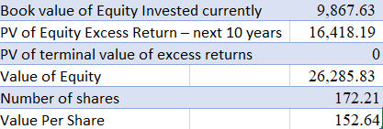

## ***Relative Model: P/E and PBV - Compared FRC with selected regional banks.***

***Choices in Multiples：***In the valuation of FRC, we insist on equity valuation of FRC instead of using Firm value multiples such as Value to EBITDA or Value to EBIT. This is because neither value nor operating income can be easily estimated for FRC or other financial service companies. Therefore, we only chose Price Earnings Ratios and Price to Book Value Ratios here.

### Price Earnings Ratios：The price to earnings ratio for FRC is the ratio of the price per share to the earning per share. For the P/E ratio, due to the special nature of banks: higher expected growth rates in earnings, higher payout ratios and lower costs of equity. Banks tend to have higher P/E ratios. Therefore, we add Expected growth in EPS and Beta as explanatory variables in linear regression. We get the following linear relationship:

* *P/E = 24.37 - 6.05 * Beta = 23.63*

According to FRC's P/E ratio of 25.3 in the fourth quarter, we believe that the price of FRC is overvalued by 7.11% compared to its peers. The actual price should be $135.26, and the value is slightly overvalued.

### Price to Book Value Ratios：The price to book value ratio for FRC is the ratio of the price per share to the book value of equity per share. We made a regression of PVB to ROE as the relationship is stronger for financial service firms than for other firms. Because in the financial services industry, the book value of equity is more likely to track the market value of equity invested in existing assets.

* PBV = 0.188877926583374 * ROE = 1.86

According to FRC's P/BV ratio of 2.5 in the fourth quarter, we believe that the price of FRC is overvalued by 34.91% compared to its peers. The actual price should be $107.38, and the value is overvalued.

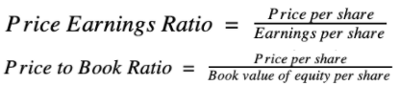

***Sensitivity analysis:*** From the table, we can see that FRC responds well to changes in Terminal growth rate and Terminal Cost of Equity. Among them, the highest value is $194.41 and the lowest value is $124.54. Compared with the target price of 145.29, the biggest change is only 33.80%. Therefore, our valuation model can better adapt to changes in the market environment.

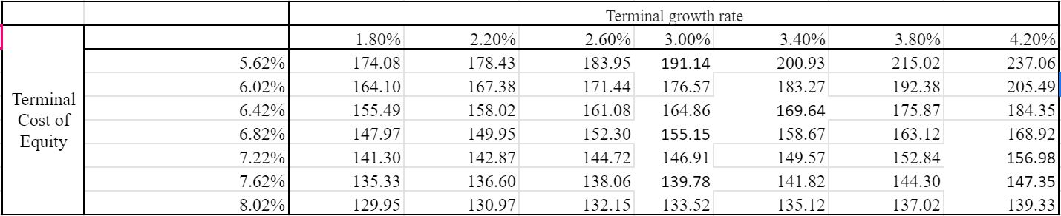

## 

## INVESTMENT RISKS---------------------------------------------------------------------------------------------------------

## As for the company itself, we are optimistic about the overall investment risk of FRC. On the company side, this depends on FRC’s excellent rating, good capital adequacy ratio, good liquidity, and excellent credit exposure. On the market side, this is due to FRC’s relatively low Beta lead to less impact from the change of ERP.

## ***Ratings:*** The first reason is FRC's excellent overall risk rating. Whether it is Moody's Rating or Standard & Poor's Ratings, FRC is significantly higher than its peers, on the edge of high-risk/junk bonds. For FRC, the bank's risk is mainly reflected in its preferred stock, and its rating is the lowest among all other banks that issue preferred stock, given its significant issuance. However, with regard to the series of actions taken by FRC to redeem preferred shares in 2020, we currently remain confident in this.

***Capital Adequacy:*** FRC’s Capital Adequacy demonstrated a slight downward trend, but remained relatively stable. Among the top 10 regional banks whose main business is commercial banks, FRC's Tier 1 Capital Adequacy remains at an average level, but the overall capital adequacy ratio is lower than its peers. This also reflects FRC's use of non-cumulative preferred stock to improve Tier 1 Capital Adequacy. Since FRC is in a stage of rapid development, we believe that this method is feasible and understandable. If there is no significant decline in the future, we remain optimistic about the current risks of its capital adequacy ratio. 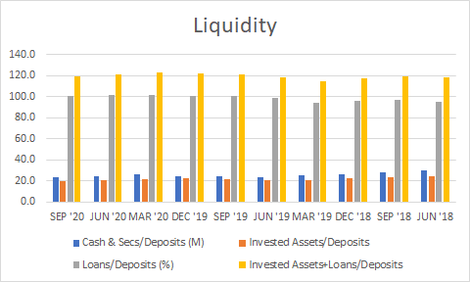

***Liquidity:*** FRC's asset liquidity maintains a relatively stable state in the last 10 Financial quarters. Compared with its peers, FRC’s cash/deposit ratio is relatively low, but the total investment assets and loan/deposit ratio is relatively low. Similarly, we recommend treating FRC with a developmental perspective, because this aspect reflects FRC's efficient fund management. A lower cash ratio shows FRC's excellent cash utilization rate, while a higher total investment assets and loans/deposits The ratio illustrates FRC's good deposit utilization rate. Therefore, we remain optimistic about liquidity risks.

***Credit Exposure:*** According to Lending Amounts by Sectors, FRC's loans have some concentration in Investment Services and Media and Publishing Services, which accounted for 99.04% of its total loans. Within them, investment services accounted for 72.98%. In the current COVID-19 epidemic, both industries are considered to be less affected in comparison to others, which indicates positive forecasts.

***Change in Capital Requirement:***Changes in global bank capital requirement with the introduction of Basel IV in January 2023-- Beside the potential financial risks related to this investment. The scheduled change in regulations for banks and financial regulations has just as much likelihood to influence the investment than the financial risks. Expected changes in the next standards are a Tier 1 capital requirement of at least 6% under standard approach, reduction in risk weight for low rate mortgages, and Leverage ratio accounting for 50% of the risk adjusted capital ratio among others.

SUSTAINABILITY--------------------------------------------------------------------------------------------------------------

***Environmental, Social, and Corporate Governance:*** Research on trends and behaviors of bank's customers show that sustainability and environmental responsibility are not considerable factors when making a decision. Despite the fact that banks should operate ethically towards the environment, the focus of that discussion is faced more often towards construction, food supplies, and production of raw materials. First Republic Bank is headquartered in California, thus it is expected to launch green initiatives. In 2019, the company announced the "Shred It" program in which they will strive to become more paperless in their daily operations—which was not highly publicized in the media but received well regardless (First Republic Bank Exhibit 99.1, 2021). The company's participation while targeting high-networth individuals may be perceived as contradictory to some. To date, however, it has not been a threat to FRC.

The ability of a banking corporation to service society and to act equitable on that front, is extremely to a bank of FRC's size. In other words, they are not too big to fail, and certainly at stakeholder risk in relation to that social aspect. Occupy Wall Street showed resistance to predatory practices by big banks and recent scandals about corporate wrongdoings like Wells Fargo shed a spotlight on the social responsibility that many banks have. It is an ongoing liability that First Republic Bank has been criticized for only focusing on wealthy clients and approving more loans to non-minorities. Despite their target demographic strategy being problematic, they plan on continuing with the path that has a successful track record. In terms of service and philanthropy, FRC has the Huckleberry Youth Program which works around the Bay Area community to supply the underprivileged population with shelter, education, and career training. Lastly, their corporate governance policies mostly revolve around limiting absurd bonuses and compensations that many C-Suite bank executives in the country receive (First Republic Bank Exhibit 99.1, 2021).. Overall, FRC's sustainability sector in environmental, social, and corporate activities are well-positioned in the right direction.

APPENDIX NETWORK

|  |  |  |
| --- | --- | --- |
| Financial Performance | Valuation | Miscellaneous |
| 1. PBV/BETA  2. PBV/ROE  3. Price to Earnings Ratios  4. Price to Book Value Ratios  5. Free Cash Flow KPI  6. Proceeds from Loan  7. Non-performing loans/Total Loans  8. Free Cash Flow  11. Free Cash Flow: Industry Comparison  16. Loan Loss Provisions/Total Loans | 9. Preferred Stock Rating: High-Risk Junk Bonds  10. Changes in Working Capital  12. Tier 1 Risk-based Capital Ratio (%)  13. Cash and Secs Deposit (M)  14. Invested Assets and Loans / Deposits  15. Lendings Amounts by Sector  17. FCFE Valuation Model  18. Weighted Valuation Matrix | 19. FRC Customer Service Review Comparison  20. SWOT Analysis  21. Porter’s Five Forces: Commercial Banking Industry  22. Citations  23. DDM Model |

APPENDIX 1: PBV/BETA

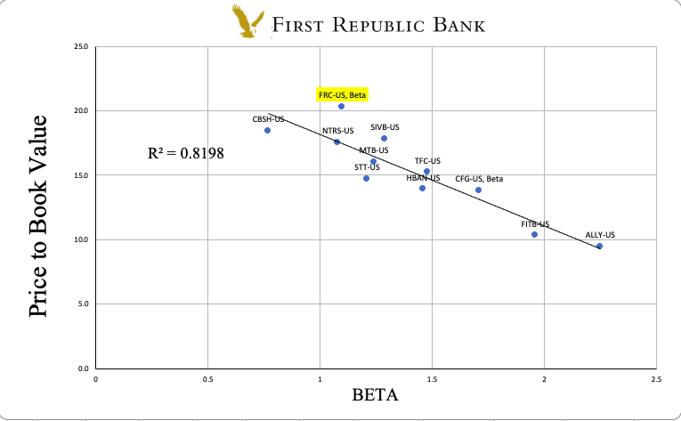

APPENDIX 2: PBV/ROE

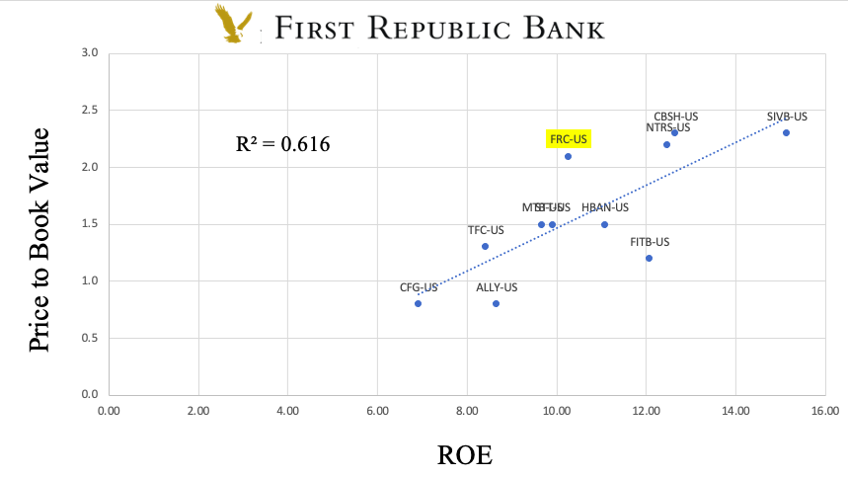

APPENDIX 3: PRICE TO EARNINGS RATIOS

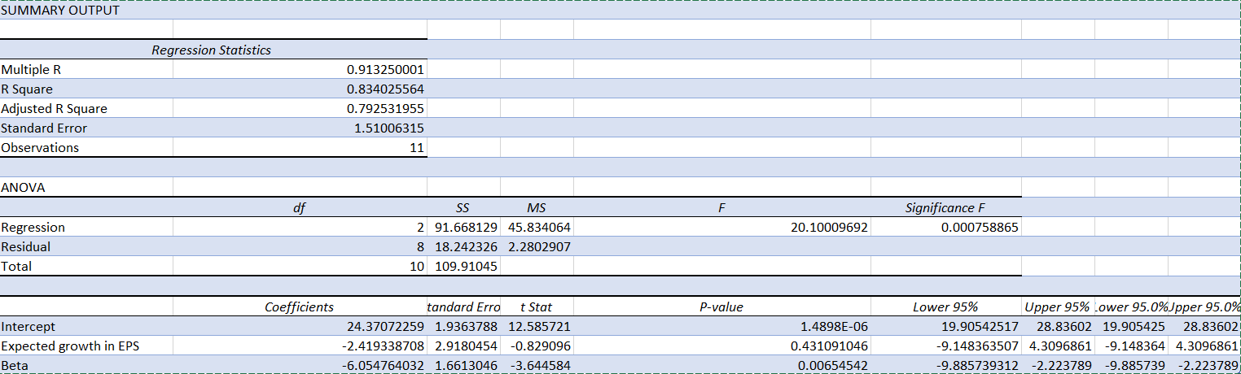

APPENDIX 4: PRICE TO BOOK VALUE RATIOS

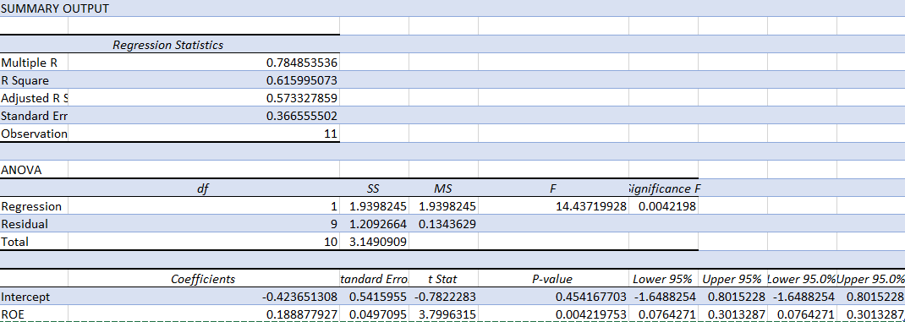

APPENDIX 5: FREE CASH FLOW KPI

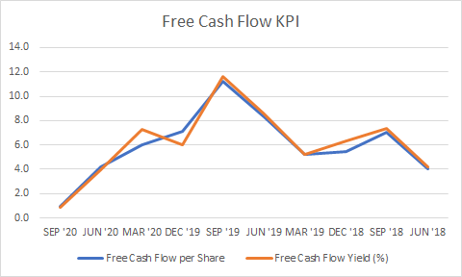

APPENDIX 6: PROCEEDS FROM LOANS

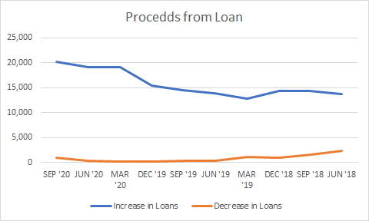

APPENDIX 7: NON-PERFORMING LOANS/TOTAL LOANS

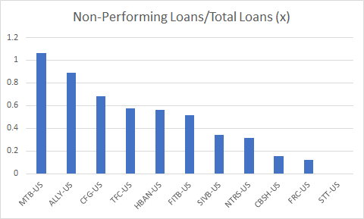

APPENDIX 8: FREE CASH FLOW

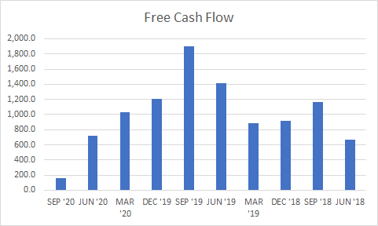

APPENDIX 9: PREFERRED STOCK RATING - HIGH-RISK JUNK BONDS

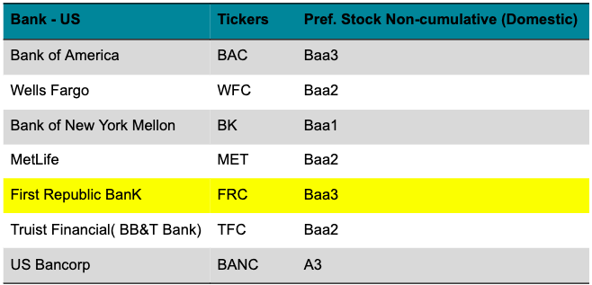

APPENDIX 10: CHANGES IN WORKING CAPITAL

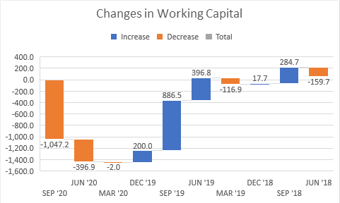

APPENDIX 11: FREE CASH FLOW - INDUSTRY COMPARISON

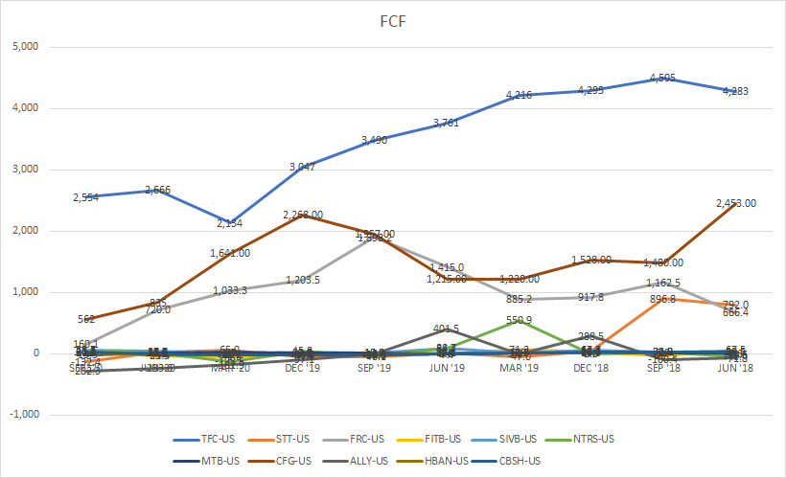

APPENDIX 12: TIER 1 RISK-BASED CAPITAL RATIO (%)

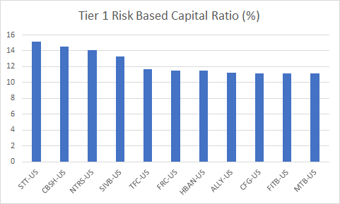

APPENDIX 13: CASH AND SECS DEPOSITS (M)

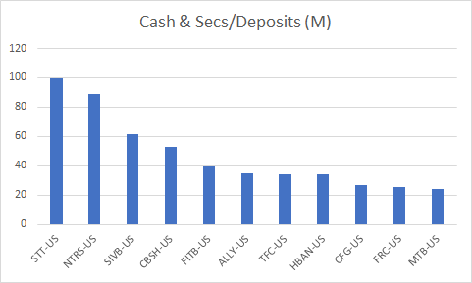

APPENDIX 14: INVESTED ASSETS + LOANS / DEPOSITS

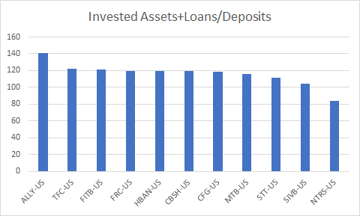

APPENDIX 15: LENDING AMOUNTS BY SECTORS

## 

APPENDIX 16: LOAN LOSSES PROVISION / TOTAL LOANS

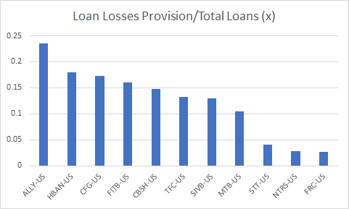

APPENDIX 17: FCFE VALUATION MODEL

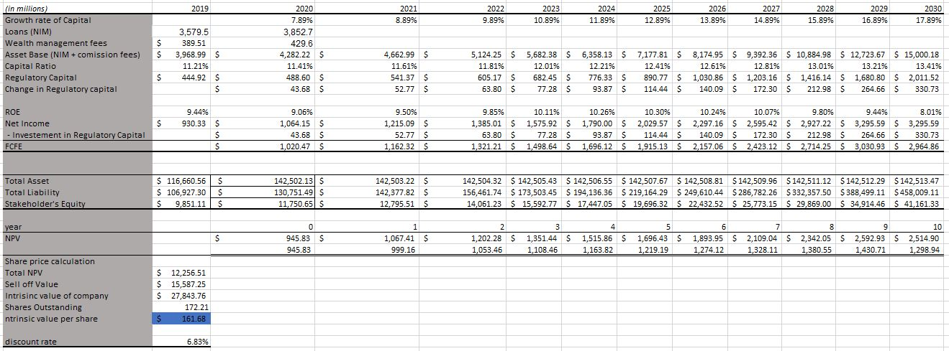

APPENDIX 18: WEIGHTED VALUATION MATRIX

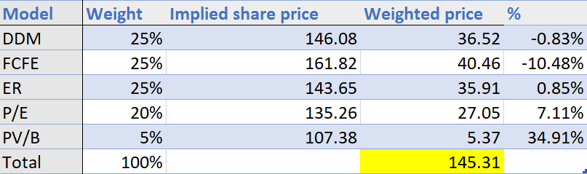

APPENDIX 19: FRC CUSTOMER SERVICE REVIEWS COMPARISON

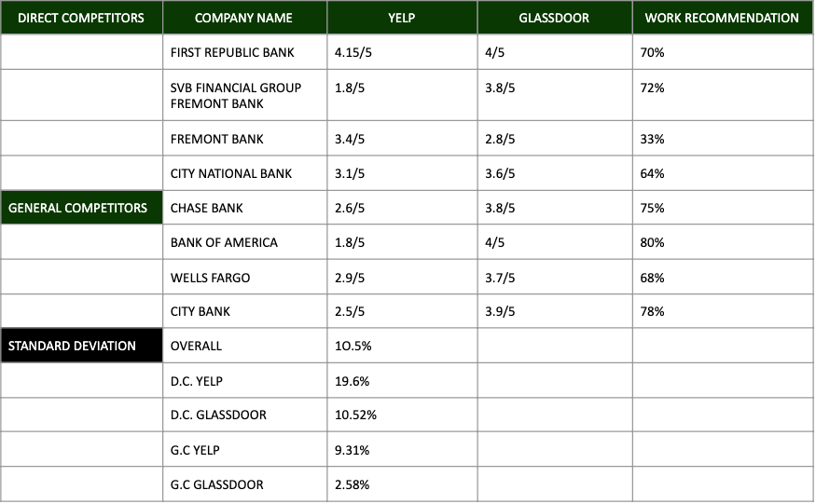

APPENDIX 20: SWOT ANALYSIS

|  |  |
| --- | --- |
| **STRENGTH** | **WEAKNESS** |
| · Outstanding creditworthiness  · Strong free cash flow (See Figure 1) | · Low liquidity as measured by loan-to-deposit value  · Limited success/innovation outside of core business |
| **OPPORTUNITIES** | **THREATS** |
| · Forecasted economic expansion should lead to increasing bank lending  · High revenue growth 2020-2025 (See Figure 2)  · Expected rising interest rate should lead to rising prime rate  · Low capital intensity compared to the sector | · Political risk: Regulations are strict and the trend is increasing  · Intense external competition from both bank and nonbank organizations  · Interest rate risk: Interest rate can affect the prime rate  · Low revenue growth 2005-2020 |

**FIGURE 1 - CASH FLOW AND FREE CASH FLOW (in millions USD)**

|  |  |  |  |  |  |
| --- | --- | --- | --- | --- | --- |
| **YEAR** | 2019 | 2018 | 2017 | 2016 | 2015 |
| **NET OPERATING CASH FLOW** | 1,371 | 1,052 | 988 | 866 | 501 |
| **NET OPERATING CASH FLOW GROWTH** | 30.41% | 6.41% | 14.12% | 72.86% | - |
| **NET INVESTING CASH FLOW** | (17,468) | (11,003) | (14,460) | (13,344) | (10,184) |
| **NET INVESTING CASH FLOW GROWTH** | -58.76% | 23.91% | -8.36% | -31.03% | - |
| **NET FINANCING CASH FLOW** | 14,985 | 10,465 | 13,142 | 13,455 | 9,997 |
| **NET FINANCING CASH FLOW GROWTH** | 43.19% | -20.37% | -2.33% | 34.59% | - |
| **FREE CASH FLOW** | 1,204 | 918 | 822 | 779 | 448 |
| **FREE CASH FLOW GROWTH** | 31.13% | 11.71% | 5.43% | 73.83% | - |
| **FREE CASH FLOW YIELD** | 5.15% | - | - | - | - |

*Source: Wall Street Journal*

**FIGURE 2 - FORECASTED REVENUE 2020-2025**

|  |  |  |
| --- | --- | --- |
| **YEAR** | **REVENUE (MILLIONS USD)** | **PERCENTAGE CHANGE** |
| 2020 | 666,002 | N/A |
| 2021 | 681,396 | 2% |
| 2022 | 723,736 | 6% |
| 2023 | 775,464 | 7% |
| 2024 | 806,248 | 4% |
| 2025 | 821,715 | 2% |

*Source: IBISWorld*

APPENDIX 21: PORTER’S FIVE FORCES: COMMERCIAL BANK INDUSTRY

|  |  |
| --- | --- |
| **BARGAINING POWER OF BUYERS** | **LOW** |
| · Switching cost for buyers may be low or high, depending on the financial product  · Switching cost is high for corporate clients  · The Internet has made it easier for individual consumers to reduce switching costs |
| **BARGAINING POWER OF SUPPLIERS** | **MEDIUM TO HIGH** |
| · High number of capital suppliers  · The main providers of capital are customer deposits; advances and loans; mortgage-backed securities; advances from other monetary organizations  · Talented and knowledgeable staff have high bargaining power |
| **THREAT OF NEW ENTRANTS** | **LOW TO MEDIUM** |
| · Opening a local bank is not difficult, but it is difficult to offer the full scope of services and products as a noteworthy bank  · Consumers tend to choose established banks with great credibility and creditworthiness  · Large, established banks develop economies of scales to reduce costs |
| **THREAT OF SUBSTITUTES** | **HIGH** |
| · Nonbank organizations can also offer financial services and products  · Switching costs may be low or high depending on the financial product |
| **RIVALRY OF EXISTING COMPETITORS** | **HIGH** |
| · The largest three banks make up only 33.8% of the industry – competitors equally balance  · High level of exit barriers |

**FIGURE 3 - COMMERCIAL BANKING INDUSTRY: PRODUCTS AND SERVICES SEGMENTATION**

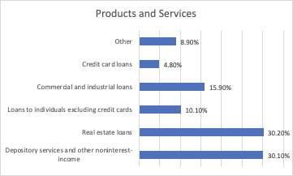

*Source: IBISWorld*

**FIGURE 4 - LEADING U.S COMMERCIAL BANKS IN REVENUE IN BILLION USD IN 2019**

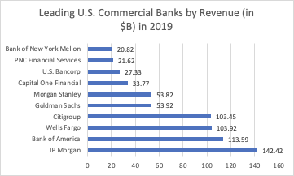

*Source: Statista*

APPENDIX 22 : FINANCIALS and VALUATIONS

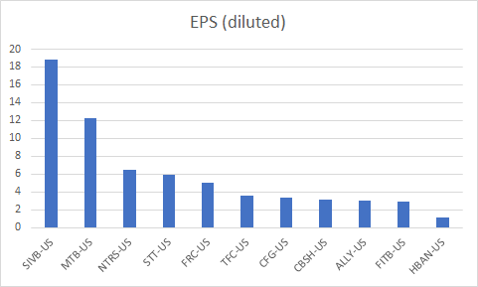

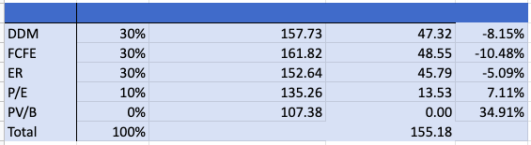

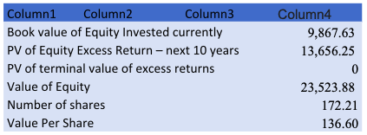

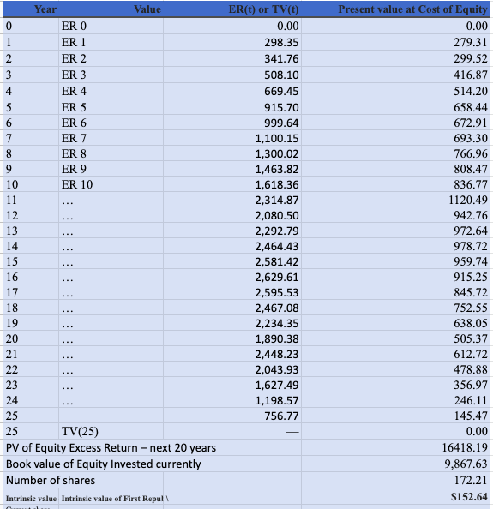

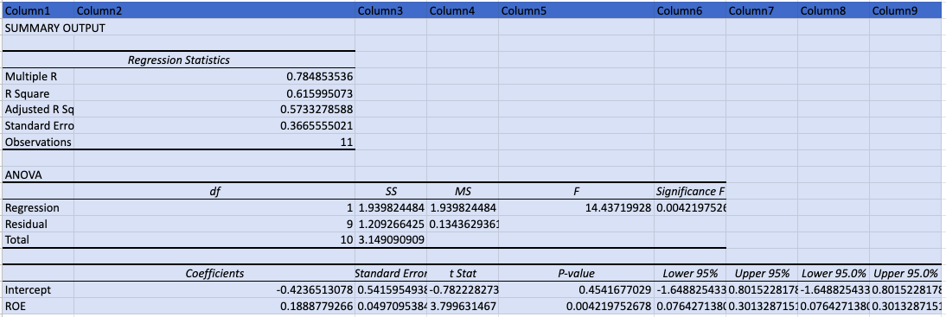

APPENDIX 23 : DDM MODEL

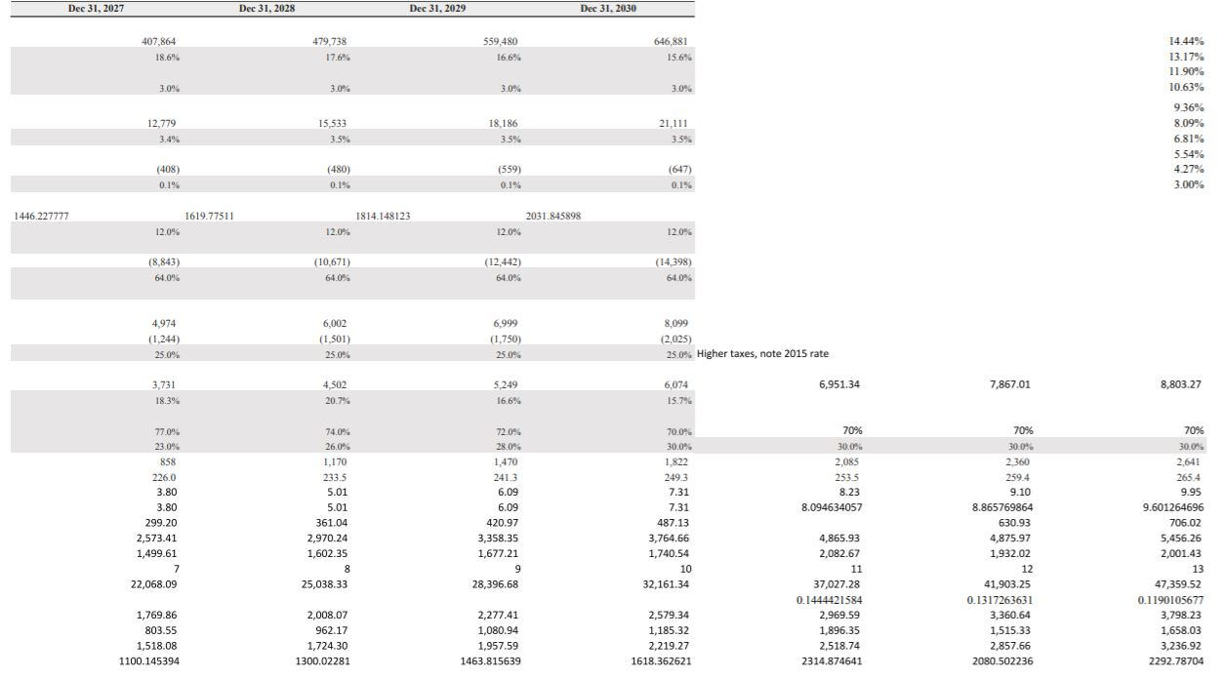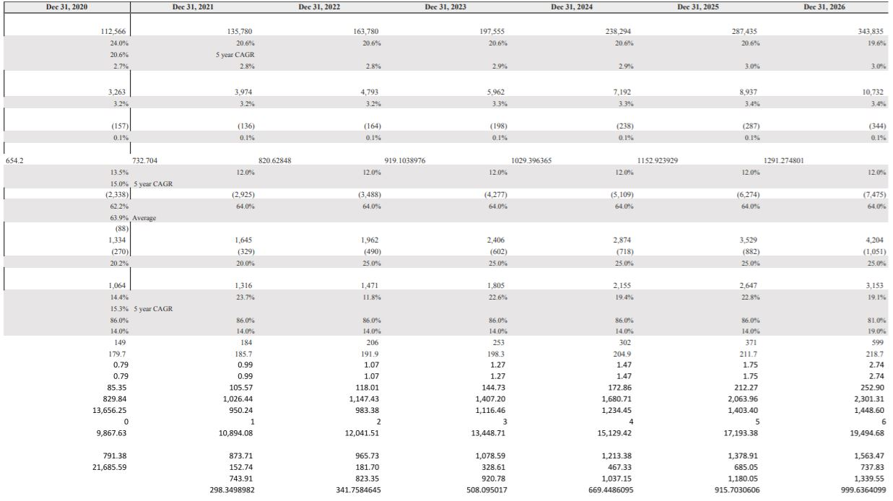



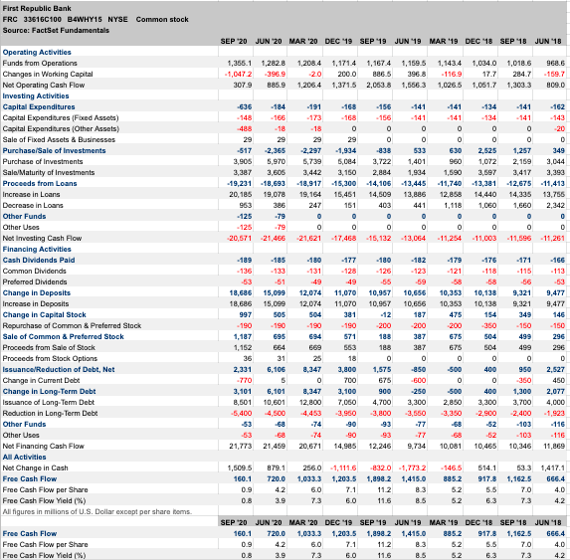

APPENDIX 23 : CITATIONS

Damodaran, A. "Implied Equity Risk Premium Update". *Damodaran Online - NYU Stern*. Retrieved from <http://pages.stern.nyu.edu/~adamodar/>.

Damodaran, A. "Valuing Financial Service" *Damodaran Online - NYU Stern*. (April 2009). Retrieved from [ttp://people.stern.nyu.edu/adamodar/pdfiles/papers/finfirm09.pdf](http://people.stern.nyu.edu/adamodar/pdfiles/papers/finfirm09.pdf).

Damodaran, A. "Valuing Financial Service Chapter 21" *Damodaran Online - NYU Stern*. (April 2009). Retrieved from [http://people.sternhttps://www.treasury.gov/resource-center/data-chart-center/interest-rates/Pages/TextView.aspx?data=longtermrate#:~:text=The%20Long%2DTerm%20Composite%20Rate%20is%20the%20unweighted%20average%20of,in%20less%20than%2010%20years..nyu.edu/adamodar/pdfiles/valn2ed/ch21.pdf](http://people.stern.nyu.edu/adamodar/pdfiles/valn2ed/ch21.pdf)

First Republic Bank. "About Us- Credit Ratings." (29 January, 2021). Retrieved from <https://www.firstrepublic.com/about-us/credit-ratings>.

First Republic Bank. "Investor Presentation, Exhibit 99.1". January 2021.

First Republic Bank. "Private Wealth Management - Eagle Invest". Retrieved from <https://www.firstrepublic.com/private-wealth-management/eagleinvest#slide-1>.

Graseck, B. L., CFA, Upadek, K., et al. *After The Storm*, Morgan Stanley, Oliver Wyman, 2020. Retrievde from <https://www.oliverwyman.com/content/dam/oliver-wyman/v2/publications/2020/jun/Global-Wealth-Management-Report-2020.pdf>

Goldberg, M. "First Republic Bank Review 2021". *Bankrate*. December, 2020. Retrieved from <https://www.bankrate.com/banking/reviews/first-republic-bank/>.

Luck, I. "Top 5 Most Recommended US Banks, Based on Net Promoter Scores". *CustomerGauge*. 14 February, 2018. Retrieved from <https://customergauge.com/blog/top-5-most-recommended-us-banks-based-on-net-promoter-scores#:~:text=First%20Republic%20Bank%2C%20NPS%20%3D%2072,Net%20Promoter%20Score%20of%2072>.

U.S. Department of the Treasury. "Daily Treasury Long Term Rate Data." (3 February 2021). Retrieved from <https://www.treasury.gov/resource-center/data-chart-center/interest-rates/Pages/TextView.aspx?data=longtermrate#:~:text=The%20Long-Term%20Composite%20Rate%20is%20the%20unweighted%20average%20of,in%20less%20than%2010%20years>

Business Wire. (2021, January 28). First Republic Bank Announces Pricing of $650 Million Series L Preferred Stock Offering. Retrieved January 30, 2021, from

mergentonline.com.

First Republic Bank. 10-K 2019, 2020. Retrieved from Ir.firstrepublic.com.

First Republic Bank (FRC) IPO Opens Higher. (2010, December 9). Retrieved January 30, 2021, from

<https://www.streetinsider.com/IPOs/First+Republic+Bank+(FRC)+IPO+Opens+Higher/6153283.html>

Rauch, Joe. “First Republic Files IPO Just Months after Buyout.” Reuters, Thomson Reuters, 29 Nov. 2010,

[www.reuters.com/article/us-firstrepublic-ipo/first-republic-files-ipo-just-months-after-buyout-idUSTRE6AS4PU20101129](http://www.reuters.com/article/us-firstrepublic-ipo/first-republic-files-ipo-just-months-after-buyout-idUSTRE6AS4PU20101129).

Gambardella, Anthoy. (2020). Commercial Banking in the US. IBISWorld. Retrieved from

[https://my-IBISWorld-com.proxy.lib.pdx.edu/us/en/industry/52211/about](https://my-ibisworld-com.proxy.lib.pdx.edu/us/en/industry/52211/about)

Maria Tor, Ali Shayan Sikander. “Loan-to-Deposit Ratio at US Banks Hits 29-Year Low as Transaction Accounts Surge.” Loan-to-Deposit Ratio at US Banks Hits 29-Year Low as Transaction Accounts Surge | S&P Global Market Intelligence, 25 June 2020,

[www.spglobal.com/marketintelligence/en/news-insights/latest-news-headlines/loan-to-deposit-ratio-at-us-banks-hits-29-year-low-as-transaction-accounts-surge-59103892#:~:text=8-reports-from-the-Federal,just-2.9%-a-year-earlier](http://www.spglobal.com/marketintelligence/en/news-insights/latest-news-headlines/loan-to-deposit-ratio-at-us-banks-hits-29-year-low-as-transaction-accounts-surge-59103892#:~:text=8-reports-from-the-Federal,just-2.9%-a-year-earlier).

Shaulova, Esther, and Lodovica Biagi. “Commercial Banks in the United States.” Statista,

[www.statista.com/study/51039/commercial-banks-in-the-united-states/](http://www.statista.com/study/51039/commercial-banks-in-the-united-states/).

“FRC | First Republic Bank Annual Cash Flow - WSJ.” The Wall Street Journal, Dow Jones & Company,

[www.wsj.com/market-data/quotes/FRC/financials/annual/cash-flow](http://www.wsj.com/market-data/quotes/FRC/financials/annual/cash-flow).